PortSwigger Web Security Academy — Proof of Concept

SQL Injection Lab 8

SQL injection attack, querying the database type and version on MySQL and Microsoft
Category | SQL Injection
Lab | Lab 8
Completed By | Security Researcher
Platform | PortSwigger Web Security Academy

Lab Objective
Extract MySQL/Microsoft database version using UNION injection.

Step-by-Step Exploitation
- Open Burp Suite and configure browser proxy.
- Navigate to the lab URL and identify the vulnerable functionality.
- Intercept the relevant HTTP request in Burp Proxy.
- Send the request to Burp Repeater for analysis.
- Craft and inject the appropriate payload into the vulnerable parameter.
- Forward the modified request and observe the response.
- Verify the exploit was successful as shown in the screenshots below.

Screenshots & Evidence
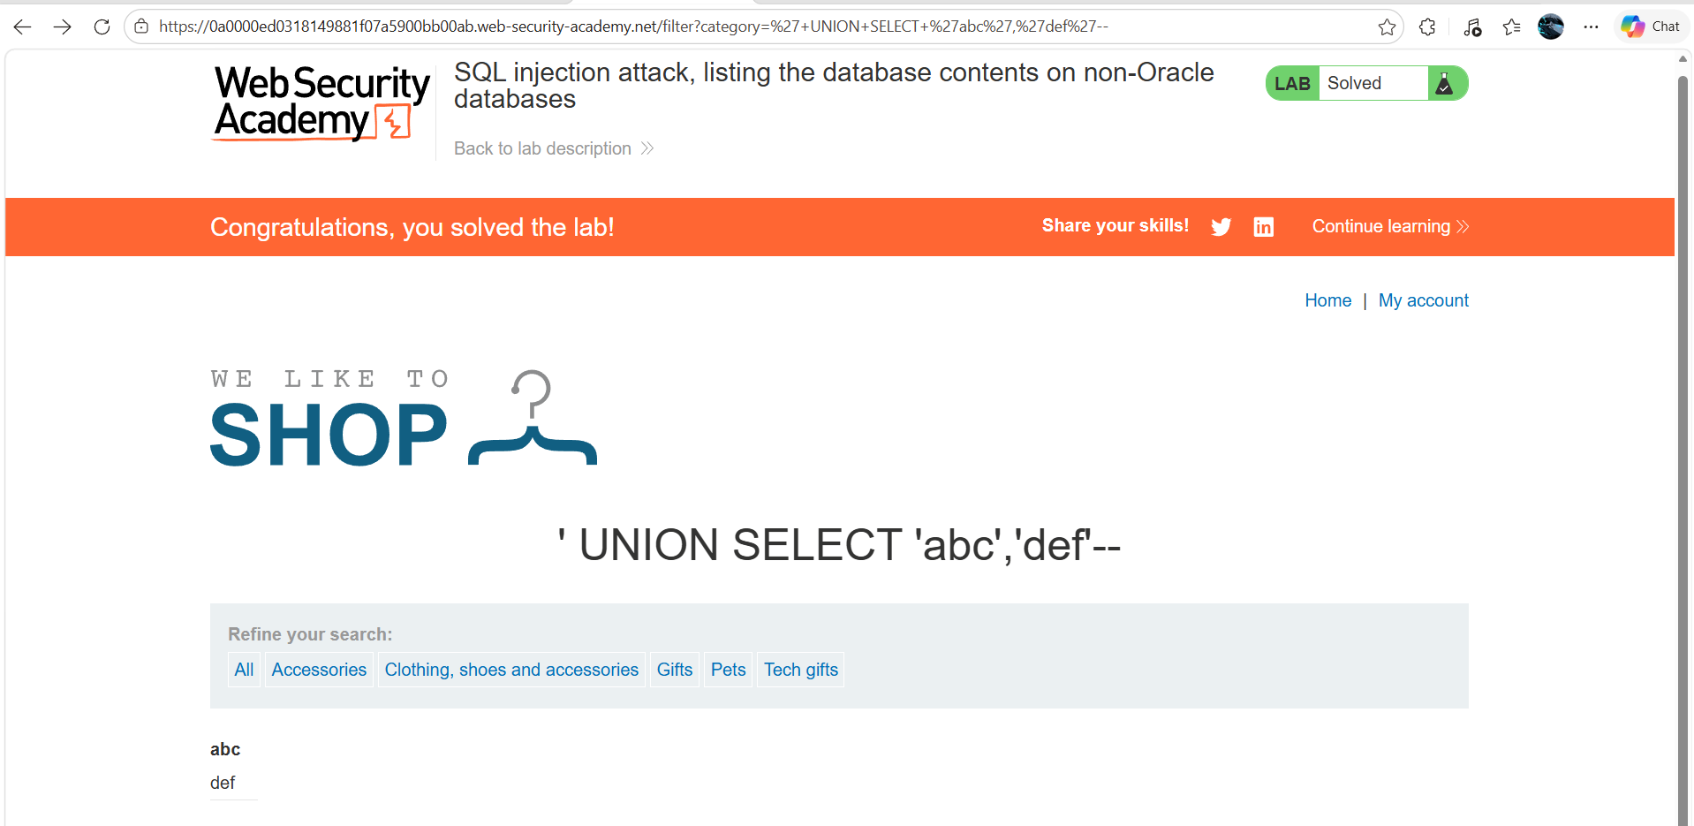
Figure 1: Checkign The SQL Injection Quarry Is Applicable
Lab Solved — Confirmation
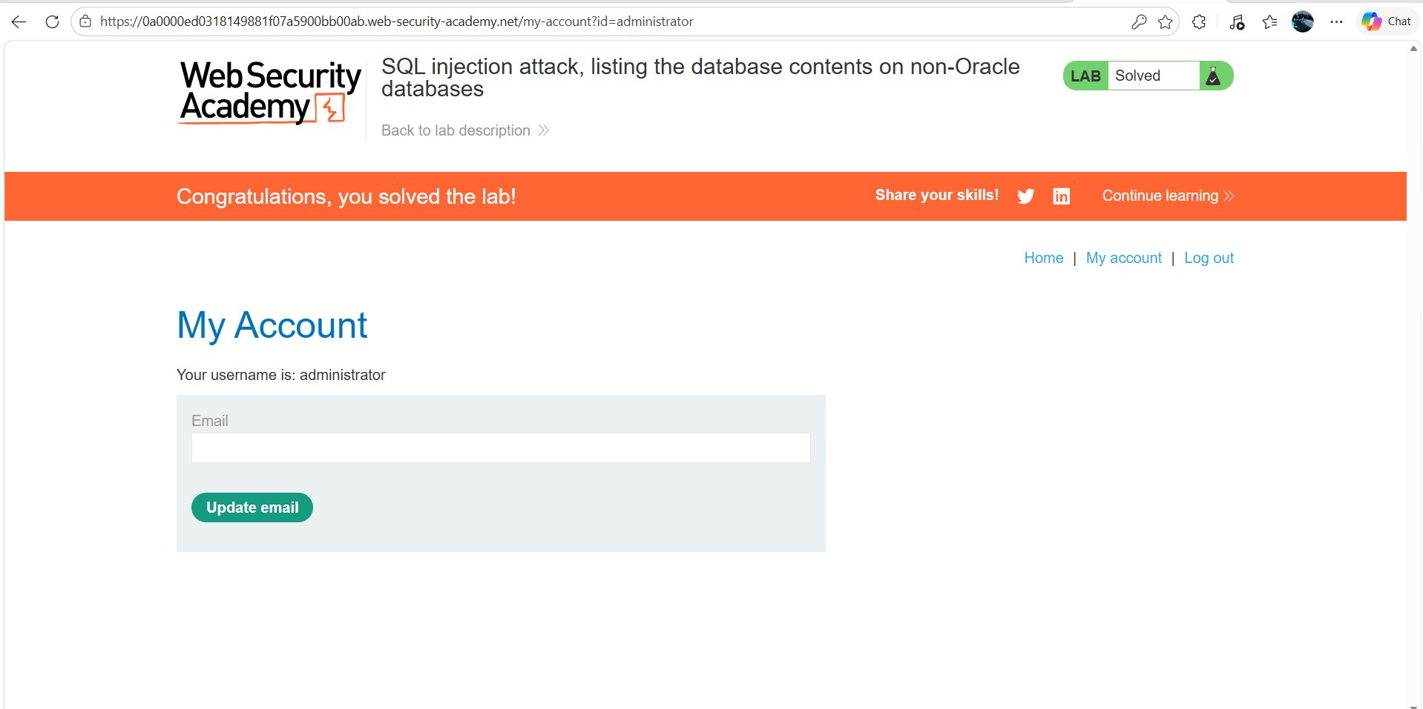
Figure 2: Lab Solved
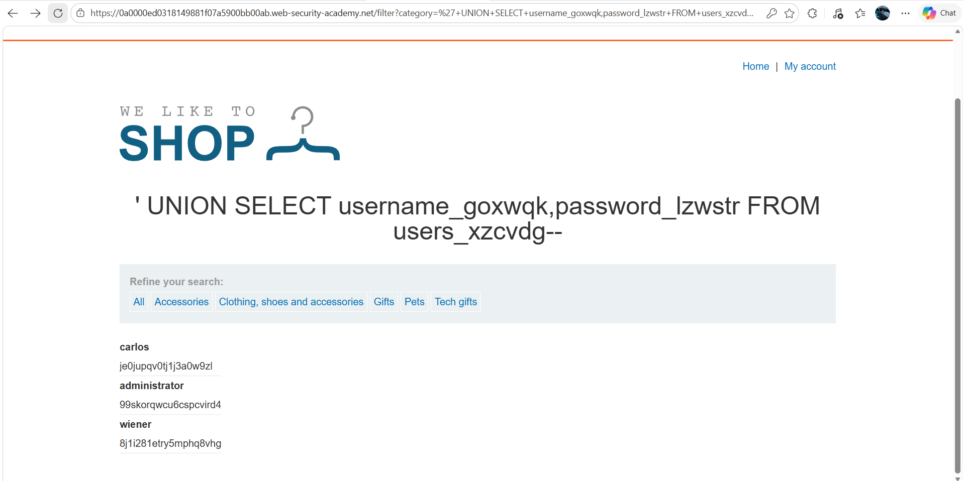
Figure 3: Modify The Request To Get Useer And Password
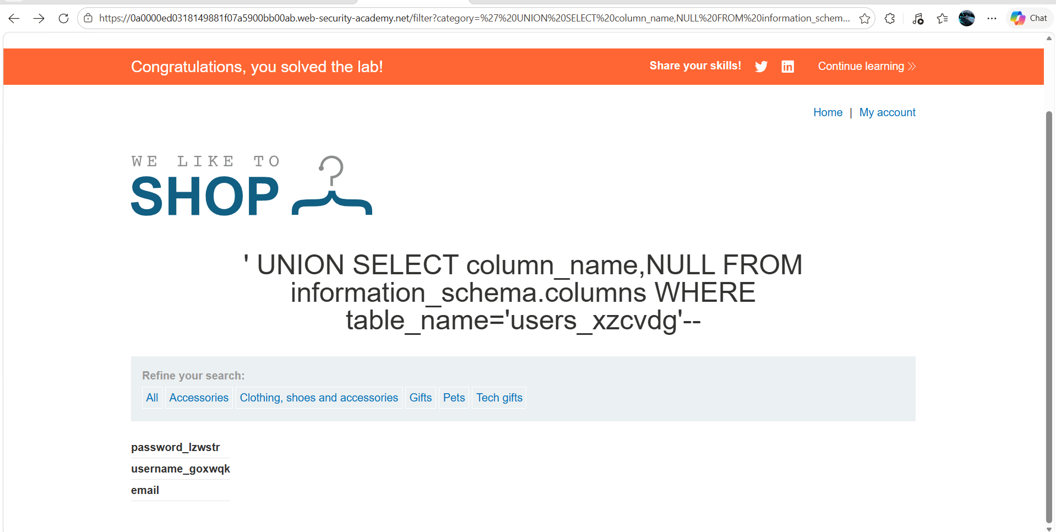
Figure 4: Password Quarry Url
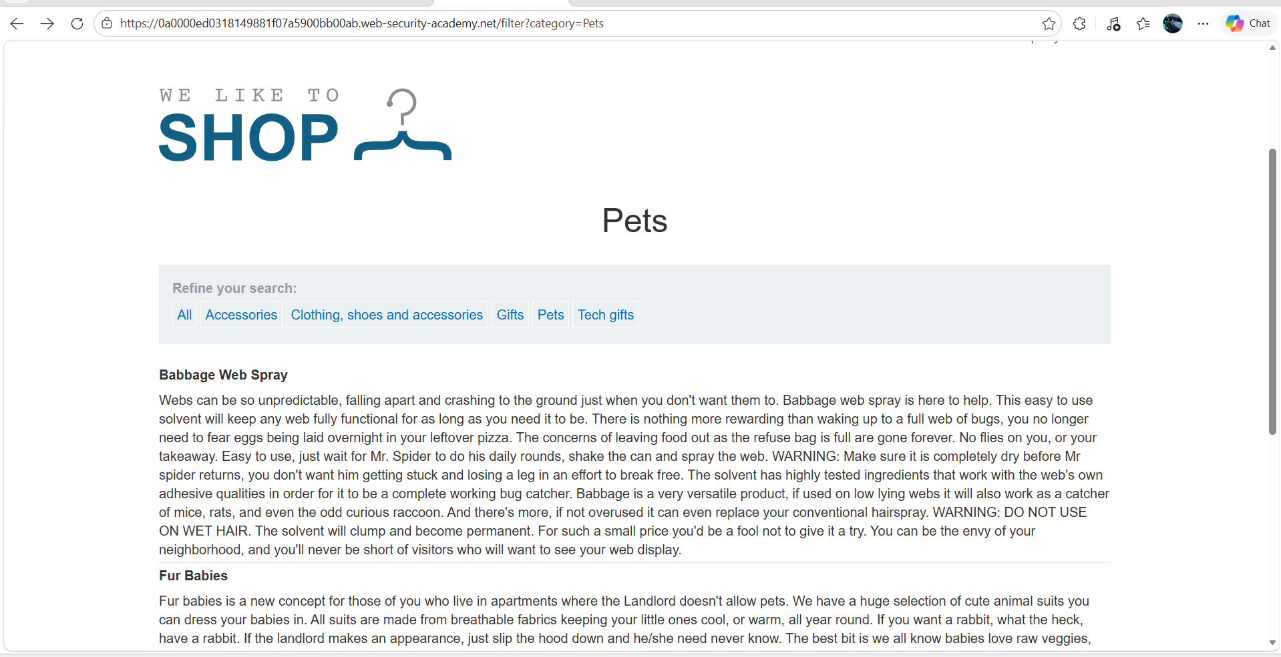
Figure 5: Select One Peremeter
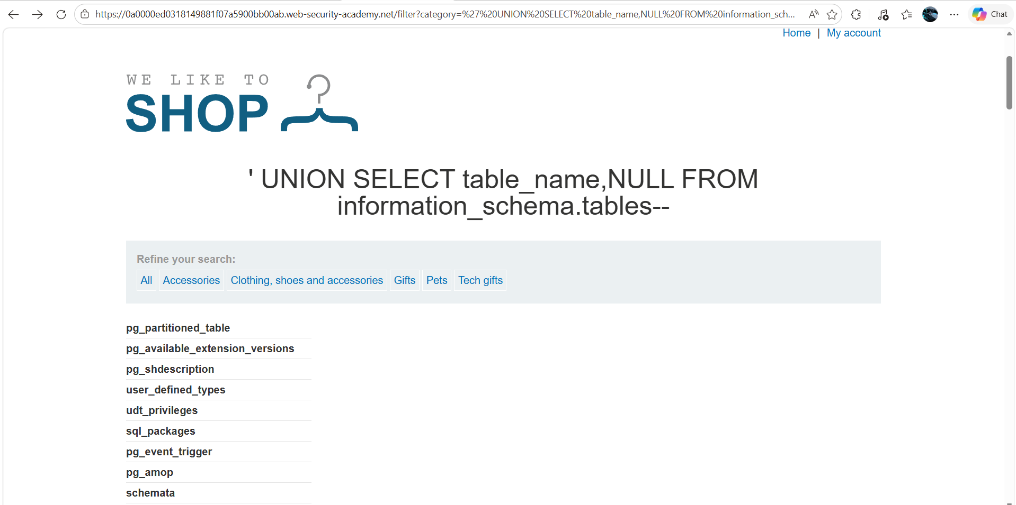
Figure 6: User Table Quarry

Lab Status: SOLVED

